PRESS RELEASE
17.12.13

Focusrite is key for Emeli Sandé

Emeli Sandé is one of the most successful international artists of the past decade - a household name in the UK, she's sold millions of records worldwide, received countless awards and was a key cultural figure in the London 2012 Olympic Games. As well as being a performing artist herself, Emeli has also written songs for the likes of Alicia Keys and Rihanna.

With such a demanding schedule, Emeli has had little time to spend at the studio and so relies upon a few go-to devices to record whilst touring. Central to her setup is one of our high-quality 2 in, 4 out interfaces: "As a travelling artist and songwriter the Focusrite Forte is great to keep working creatively and professionally whilst I'm on the road. I love the Forte for its amazing sound quality and because it's so easy to set up and use - even if you're not so tech savvy!"

Not only does Focusrite play an important role in Emeli's personal recordings, but also on stage, too. Wayne Plummer is a guitarist/arranger/musical director and has been working in the music industry for about 12 years. He's worked with some of the world's most successful artists including Estelle, Kelly Rowland, Gloria Gaynor, Craig David and most recently Emeli. Wayne's been using a range of Focusrite/Novation equipment in Emeli's recent live setup so we thought we'd find out a little more!

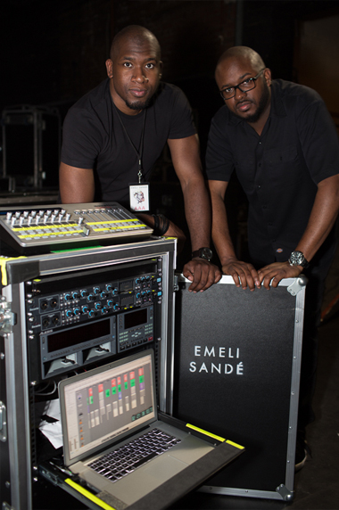
"Our touring schedule for Emeli has varied a lot - we've done a live recording at the Royal Albert Hall (5000+ capacity), smaller (1000 capacity) venues, national arenas like the Wembley O2 and festivals like Wireless which are around 20,000 cap! On top of that, we've done countless shows: Brit Awards, Clive Davis Pre-Grammy Party, Leno, Letterman, Ellen, Jonathan Ross Show and our own USA/UK/Euro tour. It's crazy having to adjust sometimes but keeps us on our toes!

For the live shows we've switched from Alesis HD24s to dual Apple Macbook Pro laptops. It's great as we can edit on the fly. We now have a programmer Wayne Hermz, which has freed me up to do MD stuff, and if Emeli wants a last minute change it can be done super-fast! The laptops run in parallel, so if one crashes the other takes over. Thankfully that has never happened (touch wood!) but you always have to plan for the worst.

I also use the Novation SL MkII Zero to control both laptops in parallel at the same time. These are great because it has many MIDI features and you can name all the songs on the screen. I see many bands using them now on the road.

Both laptops run into Focusrite Saffire Pro 40s for audio. These sound cards are great as they are super-reliable and stable. You need equipment that is as stable as the laptops and these definitely are! Not only are they reliable but sound great unlike some sound cards which sometimes colour and even dull the sound. You get a true crisp representation of the audio. Also, having 10 analogue outs is also great as you don't get this with many sound cards. This is great for playback so you can separate more audio for mixing front of house and also send separate clicks to the band and artist.

For quick recording and editing I use the Focusrite Forte. This is great as the sound you get is amazing! You can hear everything in crisp detail so you'll never hear any mistakes or pops in the audio editing. I also use it to record any extra parts the keys player can't play live.

More recently, we have been putting together a B-rig as we've been touring extensively between the US and UK. We have started implementing the new Focusrite Scarlett 18i20 for the US rig. It's great as you get the same quality as the Pro 40 but with plug and play advantage. Also, with many laptops going USB only it's useful if we have to use another machine. I have also used it to record rehearsals.

Having reliable gear can make or break a show. Imagine doing a TV performance like the Brit awards and suddenly the playback won't start! Having the best gear is a must and you can't have any less! These sound cards are perfect for the job; they have never let me down."

Contact: Hannah.bliss@focusrite.com (US)
Will.evans@focusrite.com (UK)

